Company Size and Stock Volatility
STAT 4050 Final Project | Group members: Alex Lipatov, Abdur Labik

Introduction
We examined whether smaller public companies have more volatile stocks than larger companies. Among 3,898 company observations, we showed that beginning of year market capitalization has a statistically significant negative association with annualized stock volatility in the year 2024. Doubling company size corresponds to approximately 9.88% lower volatility. This supports our hypothesis yet it does not prove causation.
We measure company size using common-equity market capitalization, the market value of shares multiplied by the count. We measure risk using the variability of daily stock returns. Higher volatility means larger fluctuations in either direction; it does not directly measure expected returns or bankruptcy risk.
Smaller businesses may depend on fewer products, while larger companies may have more diversified portfolios. These possibilities motivate our question. Campbell et al. (2001) examine market, industry, and firm-level volatility. Schwert (2002) considers technology and firm size when studying Nasdaq volatility. Both studies provide context for our analysis.

Data and cleaning
We use the CRSP U.S. Stock database through Wharton Research Data Services (WRDS), specifically crsp.dsf_v2. The download covers December 29, 2023 through December 31, 2024. Size is measured on December 29, 2023, and volatility uses daily total returns during 2024.
PERMNO identifies a stock and PERMCO identifies its company. For companies with several share classes, we sum capitalization and use the largest class’s returns, keeping one observation per company. DlyCap is also converted from thousands of dollars to dollars.
We import the CSV with read.csv() and use dplyr to filter, summarize, and join observations. We convert dates and numeric columns, check duplicate stock records, and leave missing returns as missing. Simple returns below −100% are invalid. CIZ returns already incorporate delisting returns, so we do not add them again.
We require an arbitrary minimum of at least 60 valid daily returns. Later delisted stocks remain eligible when they meet this requirement. Annualized volatility equals the sample standard deviation of daily returns multiplied by the square root of 252, then by 100 to express it as a percentage. Thus, 30 means 30% annualized volatility, not a 30% annual return. The final sample contains 3,898 companies. 252 represents the amount of trading days in our observed trading period.

Data analysis
The three ggplot2 graphs describe the sample.
The histogram displays baseline capitalization on a logarithmic axis so companies with very different dollar values are visible. The distribution, with the log x-axis, is approximately normal.
The scatterplot compares annualized volatility with log capitalization and includes the fitted regression line. Each point represents one company. Annualized volatility, by definition, cannot be negative. The linear regression line passes into the negative, thus, a non-linear test might have worked better.
The boxplot compares volatility across the smallest, middle, and largest thirds ranked by size. These are sample relative groups. The graph shows medians, spread, and outliers. Actual group medians and distribution shapes must be read from the graphs or summary table. This graph does a great job at showing how the volatility not only decreases, but tightens as well with increased company size.

Statistical analysis and results
We fit a simple linear regression of annualized volatility in percent on natural log capitalization using lm(volatility_percent ~ log_size). The null hypothesis is that the slope equals zero, tested against a two-sided alternative. Our expected direction is negative, meaning lower average volatility among larger companies.
The fitted model predicts annualized volatility as 358.1156 - 14.2579 * ln(company capitalization). The table returns the coefficients and OLS uncertainty.

Term | Estimate | Std error | p value | 95% confidence interval
Intercept | 358.1156 | 6.9230 | < 2 × 10⁻¹⁶ | 344.54247 to 371.68868
Log size | −14.2579 | 0.3397 | < 2 × 10⁻¹⁶ | −14.92401 to −13.59185

The slope’s t-statistic is approximately −41.97, with p < 2 × 10⁻¹⁶. We reject the null hypothesis at the 5% level under the model’s assumptions. The 95% confidence interval is −14.92401 to −13.59185, it’s entirely negative, proving a negative size to volatility association.
Doubling capitalization increases natural log size by log(2). Multiplying the slope by log(2) gives an estimated volatility difference of −9.88%, with a 95% interval of approximately −10.34% to −9.42%. This is the same fitted difference for doubling size from $1 billion to $2 billion or from $10 billion to $20 billion. It is a percentage point difference, not a 9.88% relative decrease.
R-squared is 0.3113, so log size explains 31.13% of the variation in volatility within this sample. The remaining 68.87% is unexplained by the model. The overall F-statistic is approximately 1,761 with 1 and 3,896 degrees of freedom. With one predictor, it tests the same slope hypothesis.
The residual standard error is 54.69%, and the largest reported residual is approximately 809.93%. Statistical significance does not imply accurate predictions for every company.

Conclusion and limitations
Our results support the hypothesis that smaller companies tend to have higher stock volatility during 2024. The estimated difference is statistically significant, but company size provides only a partial explanation of risk.
The regression identifies an association, not a causation. It omits important factors such as: industry, company age, profitability, liquidity, and more. Which could all relate to both size and volatility. Standard errors also rely on regression assumptions.
We study one year and total stock volatility rather than company specific risk alone. The coverage excludes some short histories, and partial year stocks experience different calendar windows. Repeating the analysis for another year or within one industry would help assess whether the relationship persists.

Figures
Figure 1 Distribution of company size
Histogram of baseline capitalization with a logarithmic x-axis.
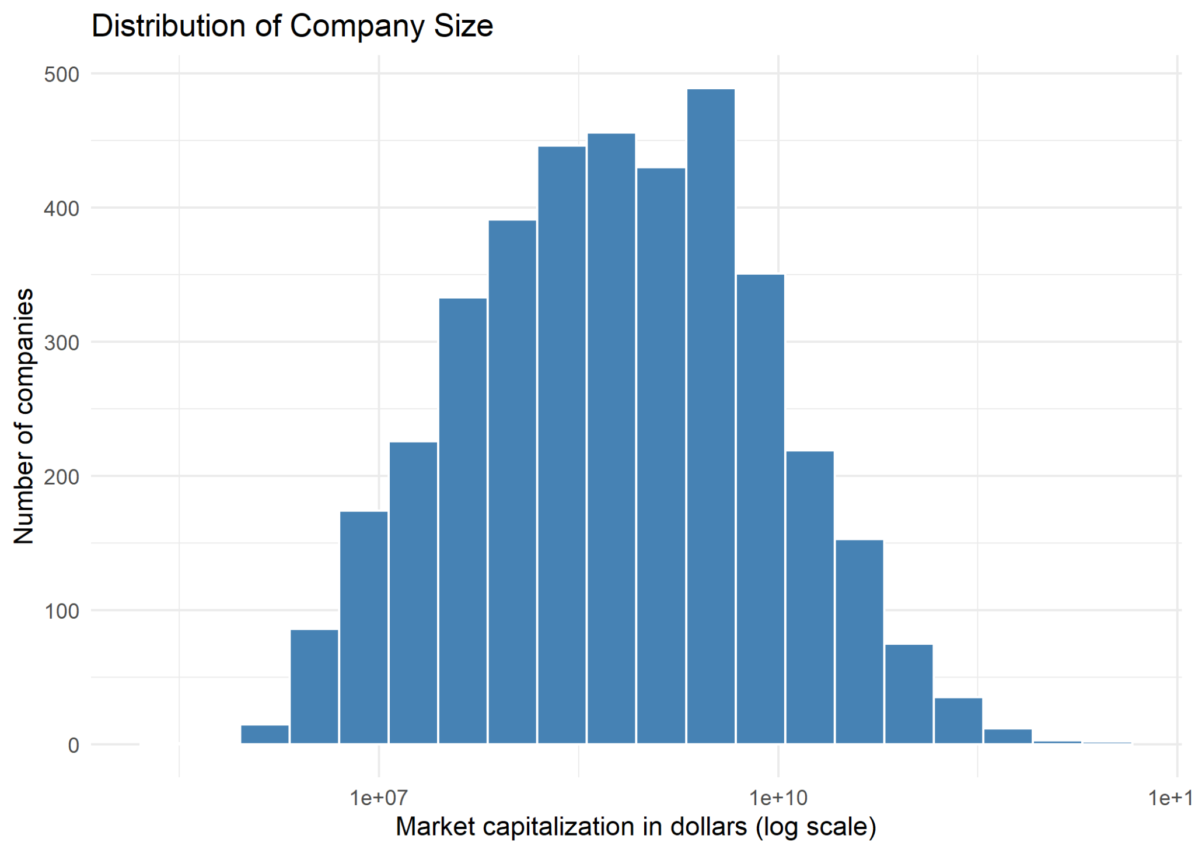
Figure 2 Company size and stock volatility
Scatterplot of natural log capitalization against annualized volatility with the fitted regression line.
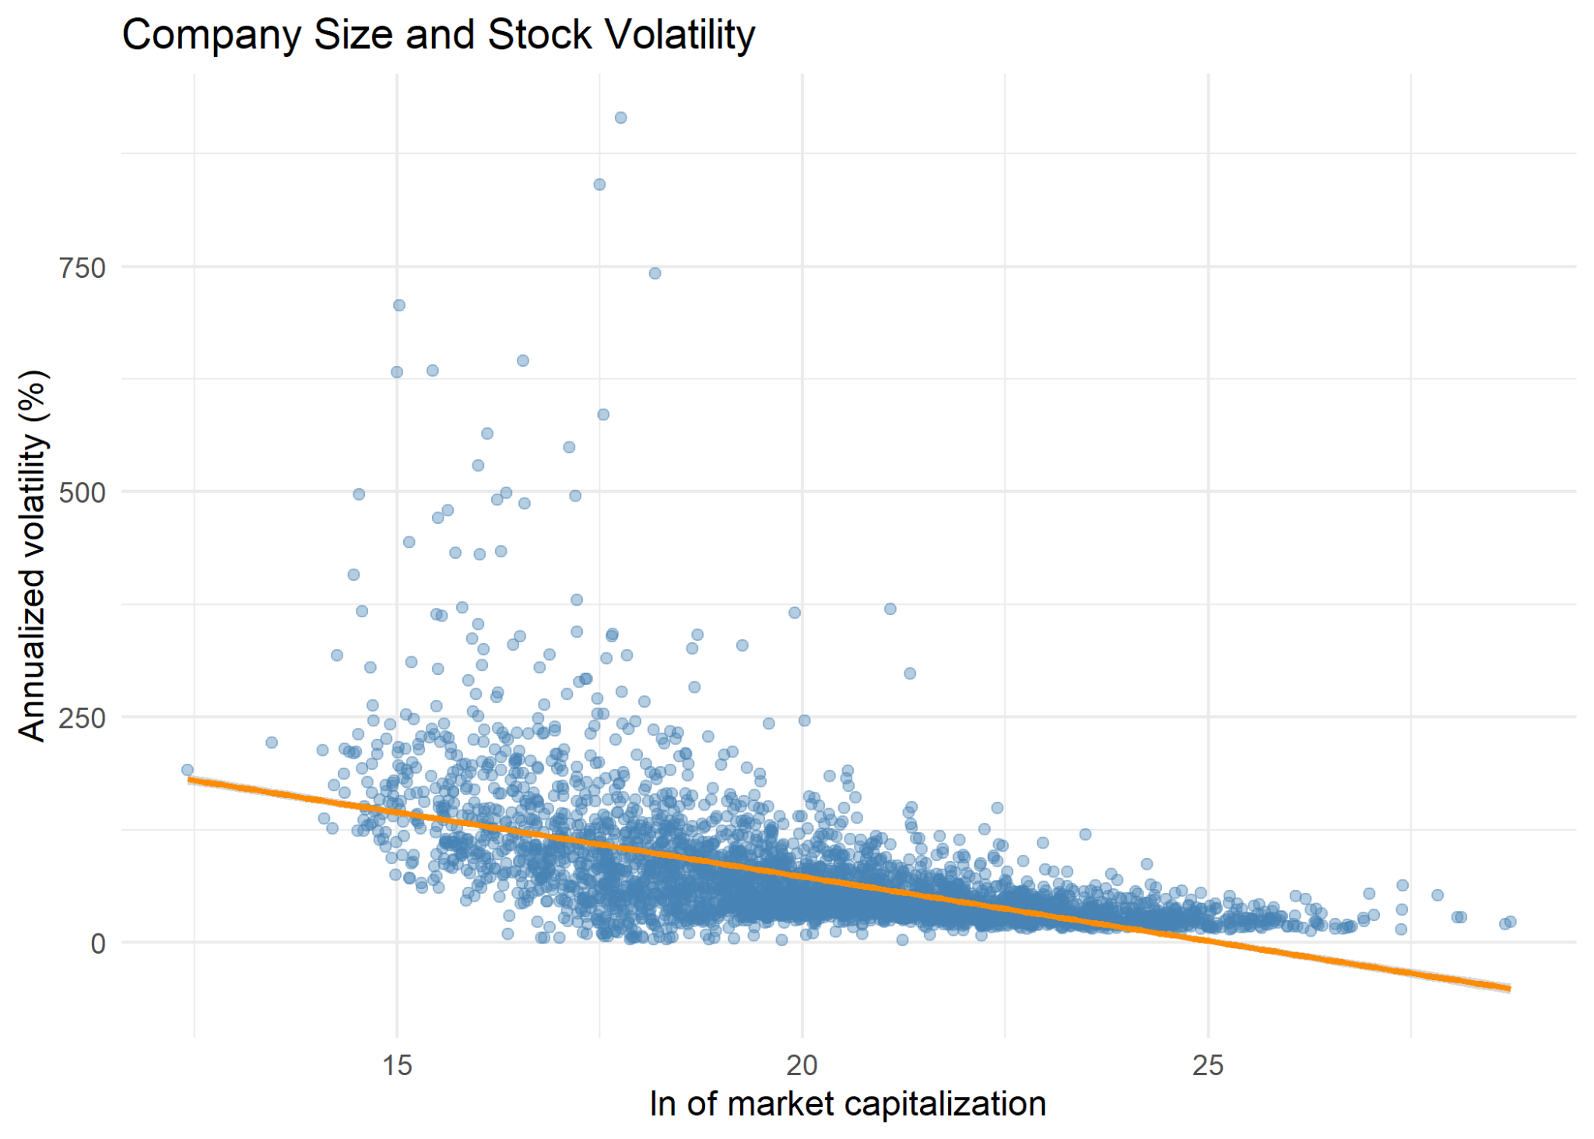
Figure 3 Volatility by company size group
Boxplots for the smallest, middle, and largest sample thirds ranked by baseline capitalization.
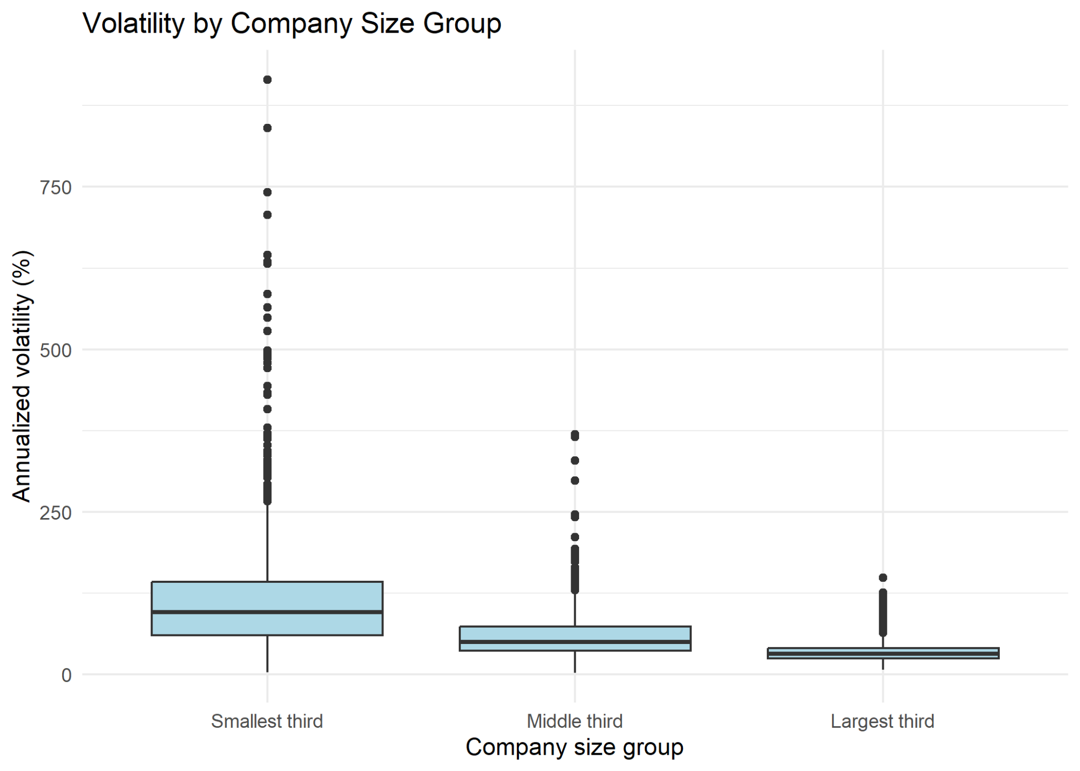

Group contributions
Alex Lipatov: data collection, data cleaning, statistical analysis, graphics, report.
Abdur Labik: presentation.

References
Center for Research in Security Prices. CRSP U.S. Stock & Indexes Database [Data set; CIZ daily stock table, December 2023–December 2024]. Wharton Research Data Services. https://wrds-www.wharton.upenn.edu/
Campbell, J. Y., Lettau, M., Malkiel, B. G., & Xu, Y. (2001). Have individual stocks become more volatile? An empirical exploration of idiosyncratic risk. The Journal of Finance, 56(1), 1–43. https://www.nber.org/papers/w7590
Schwert, G. W. (2002). Stock volatility in the new millennium: How wacky is Nasdaq? Journal of Monetary Economics, 49(1), 3–26. https://www.nber.org/papers/w8436
Wharton Research Data Services. (2026). CRSP CIZtoSIZ macro. https://wrds-www.wharton.upenn.edu/pages/wrds-research/macros/crsp-ciztosiz-macro/

